Project 2:-

Create and Query a NoSQL Table :-

In this project, we will learn how to create a simple table, add data, scan and query the data, delete data, and delete the table by using the [DynamoDB console](https://console.aws.amazon.com/console/home?region=us-east-1). DynamoDB is a fully managed NoSQL database that supports both document and key-value store models. Its flexible data model, reliable performance, and automatic scaling of throughput capacity make it a great fit for mobile, web, gaming, ad tech, IoT, and many other applications

## **Step 1: Create a NoSQL Table**

First open *DynamoDB*from all services choose to open.

In this step, you will use the DynamoDB console to create a table.

1. In the DynamoDB console, choose Create table.

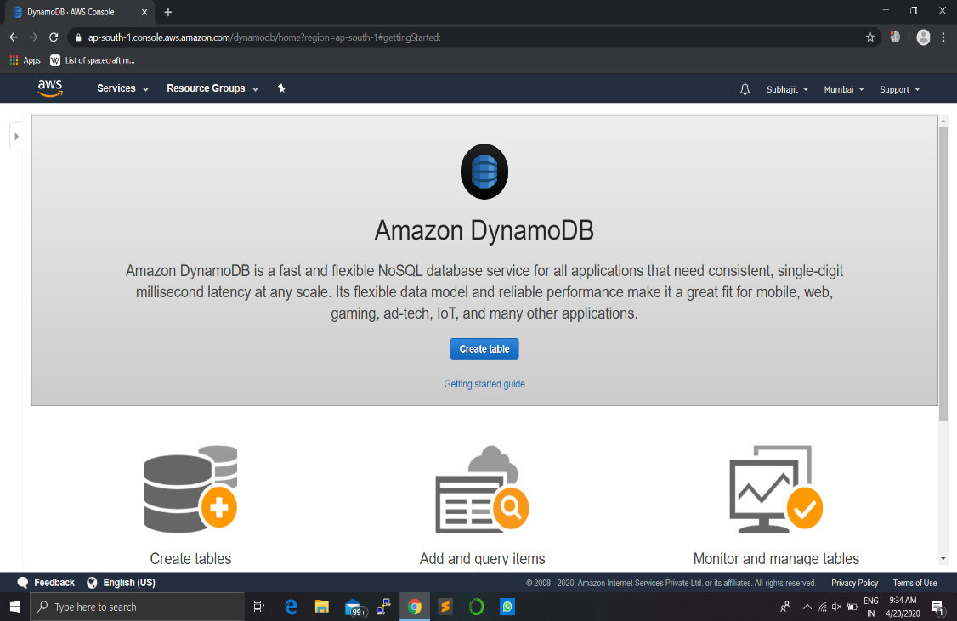

1. We will use a student details as our use case . In the Table name box, type Student*.*

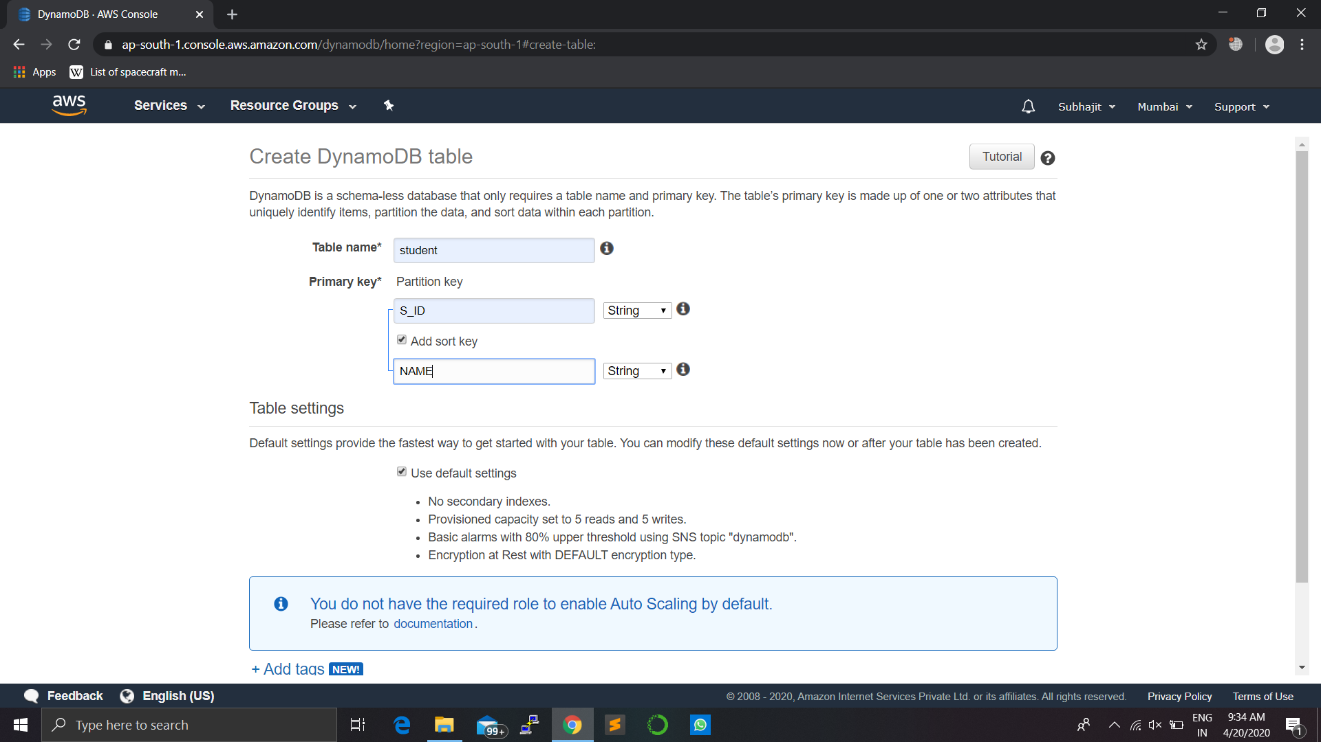

1. The partition key is used to spread data across partitions for scalability. It’s important to choose an attribute with a wide range of values and that is likely to have evenly distributed access patterns. Type *S_ID* in the Partition key box.



1. Because each studenet may have too many identity, you can enable easy sorting with a sort key. Select the Add sort keycheck box. Type NAME in the Add sort keybox for identify each student.
2. e. Next, you will enable DynamoDB auto scaling for your table.
3. DynamoDB auto scaling will change the read and write capacity of your table based on request volume. Using an AWS Identity and Access Management (AWS IAM) role called *DynamoDBAutoscaleRole*, DynamoDB will manage the auto scaling process on your behalf. DynamoDB creates this role for you the first time you enable auto scaling in an account.
4. Instruct DynamoDB to create the role by clearing the Use default settings check box.

## **Step 2: Add Data to the NoSQL Table:-**

a. Select the Items tab. On the Items tab, choose Create item .

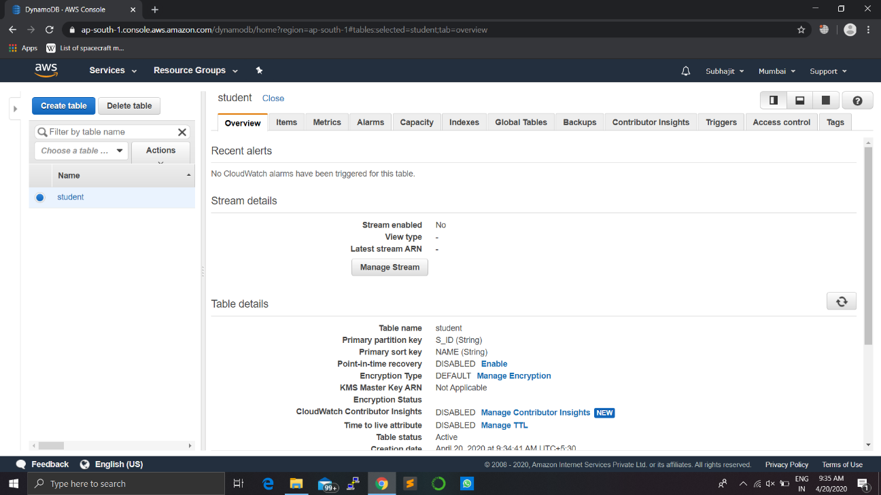

b. In the data entry window, type the following:

* For the S_ID attribute, type *s001.*
* For the NAME attribute, type *xyz.*

Choose Save to save the item

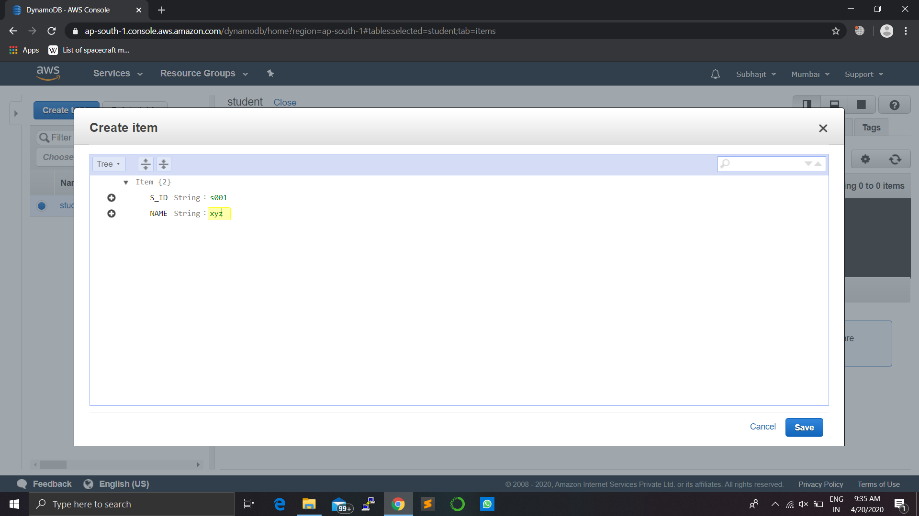

c. Repeat the process to add a few more items to your *Music* table:

* S_ID:*s002* NAME:xxy
* S_ID:*s003* NAME:yyx

## **Step 3: Query the NoSQL Table:-**

1. In the drop-down list in the dark gray banner above the items, change Scan to Query

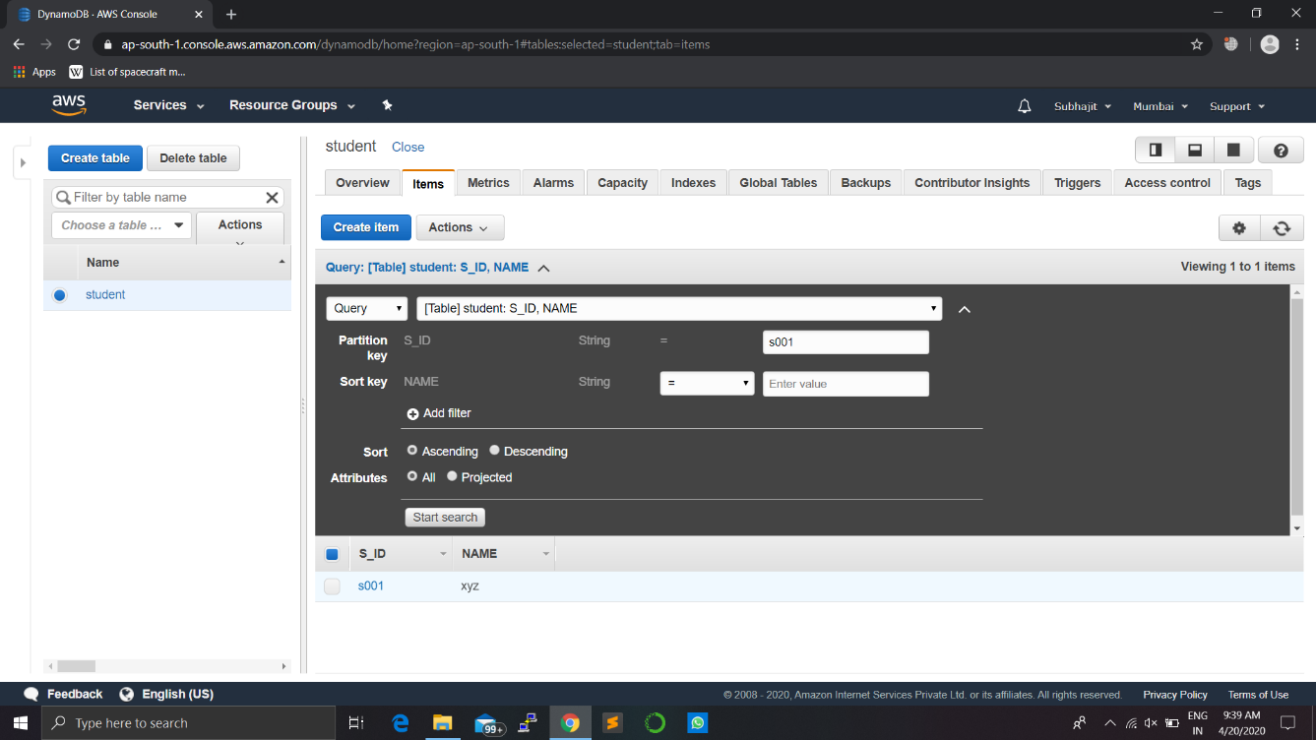

 b. You can use the console to query the S_ID table in various ways. For your first query, do the following:

* In the S_ID box, type *s001*, and choose Start search. All the name realte

To that S_ID will displayed there.

Try another query then

## **Step 4: Delete an Existing Item:-**

a. Change the Query drop-down list back to Scan.

Select the check box next to *s001*. In the Actions drop-down list, choose Delete. You will be asked whether to delete the item. Choose  Delete and your item is deleted.

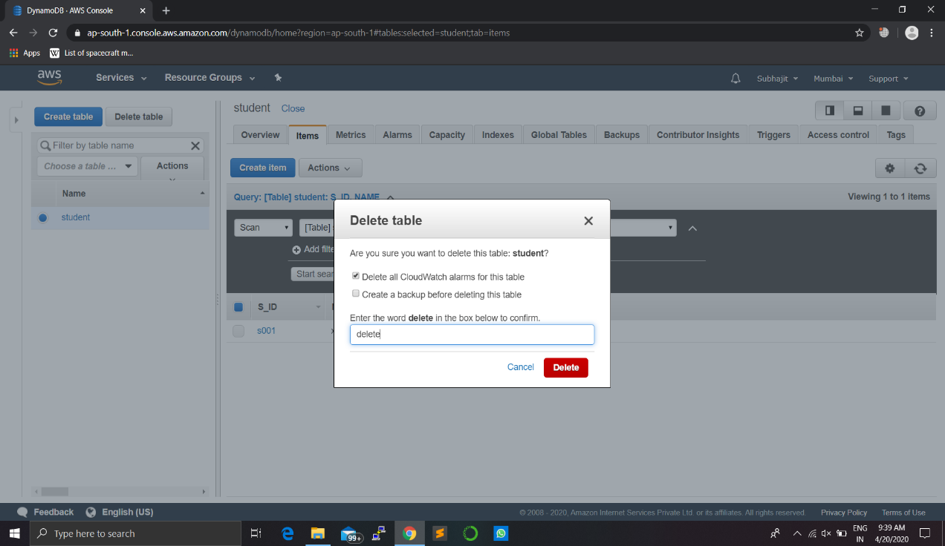

## **Step 5: Delete a NoSQL Table:-**

. You can easily delete a table from the DynamoDB console. It is a best practice to delete tables you are no longer using so that you don’t keep getting charged for them.

* In the DynamoDB console, choose the option next to the Music table and then choose Delete table.
* In the confirmation dialog box, choose Delete.

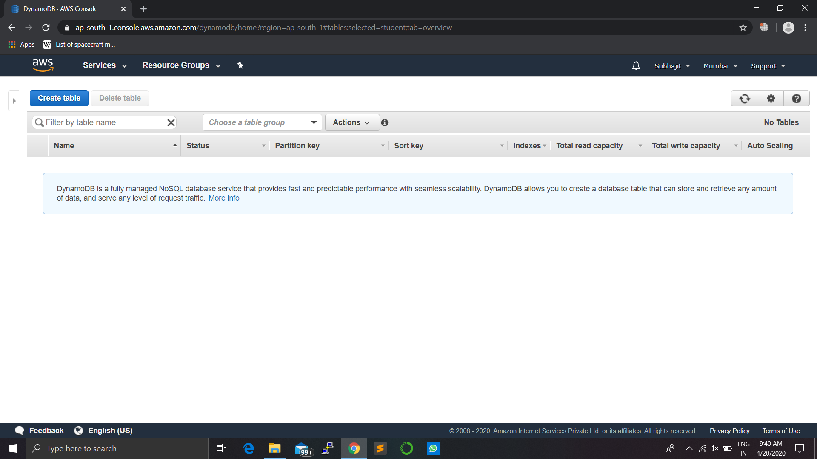

****************END****************